Wonder Woman: Echoes of Olympus

# Characters introduction

## Diana

Role: Wonder Woman  
Background: A powerful Amazon warrior princess and daughter of Queen Hippolyta. Diana is a symbol of strength, courage, and compassion, dedicated to protecting the world from evil.

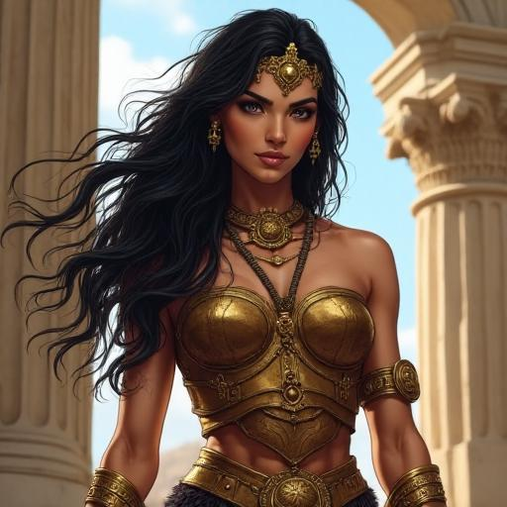

## Artemis

Role: Mentor and Warrior  
Background: A seasoned Amazon warrior and Diana's mentor. Artemis is wise, skilled in combat, and deeply loyal to the Amazon traditions.



## Cassandra

Role: Seer and Guide  
Background: A mysterious seer with the ability to see glimpses of the future. Cassandra provides crucial insights and guidance to Diana on her quest.

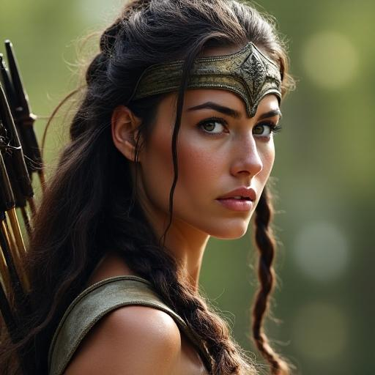

## Ares

Role: Rival and Dark Demigod  
Background: A powerful and cunning demigod seeking to overthrow the gods of Olympus. Ares is Diana's main adversary, driven by ambition and a thirst for power.



# Chapter 1: The Call of Themyscira

The comic opens with Diana Prince, also known as Wonder Woman, living in the modern world. One day, she receives a mysterious message from her mother, Queen Hippolyta, that Themyscira, the hidden island of the Amazons, is in grave danger. The message is cryptic but urgent, hinting at a threat that could destroy her homeland. Diana, feeling a deep sense of duty and concern, decides to return to Themyscira to investigate. She leaves her modern life behind, knowing that her homeland needs her. Upon her arrival, she is greeted by Artemis, her mentor and a seasoned Amazon warrior. Artemis informs her of the recent troubles on the island, detailing the strange occurrences and the rising tension among the Amazons. Artemis's stoic demeanor belies a deep concern for the safety of their people. Diana feels a renewed resolve, knowing that she must uncover the truth and protect her homeland. Together, Diana and Artemis begin to unravel the mystery, each step bringing them closer to uncovering the dark force threatening Themyscira. The chapter ends with Diana and Artemis preparing to embark on their journey, their determination unwavering as they face the unknown dangers ahead.

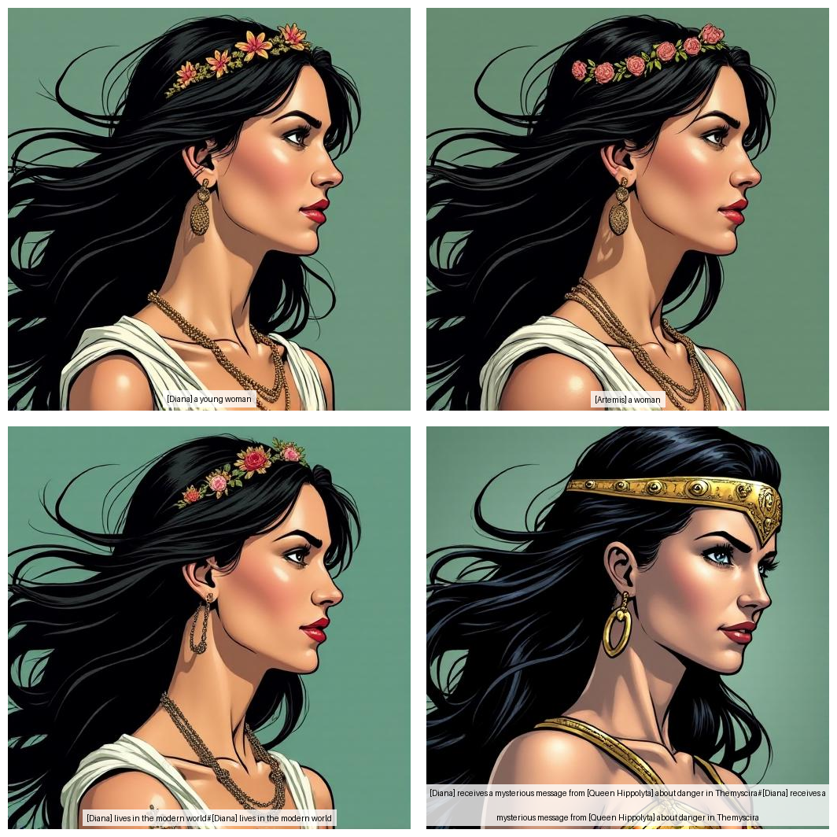

# Chapter 2: The Stolen Artifact

Diana discovers that a powerful artifact, the Heart of Olympus, has been stolen. This artifact is crucial for maintaining the island's protective barrier, and its loss could spell disaster for Themyscira. Diana and Artemis embark on a quest to retrieve the artifact, determined to save their homeland. As they journey, they face various challenges and ancient mythical creatures. Each obstacle tests their strength and wit, but Diana's unwavering courage and Artemis's battle prowess help them overcome every hurdle. Midway through their journey, they encounter a mysterious figure who introduces herself as Cassandra, a seer with the ability to see glimpses of the future. Cassandra's arrival is shrouded in mystery, but her insights prove crucial. She guides them with cryptic yet invaluable advice, helping them avoid deadly traps and make strategic decisions. Together, Diana, Artemis, and Cassandra forge ahead, their resolve unshaken. They know that the fate of Themyscira rests on their shoulders, and they are determined to restore the Heart of Olympus before it's too late.

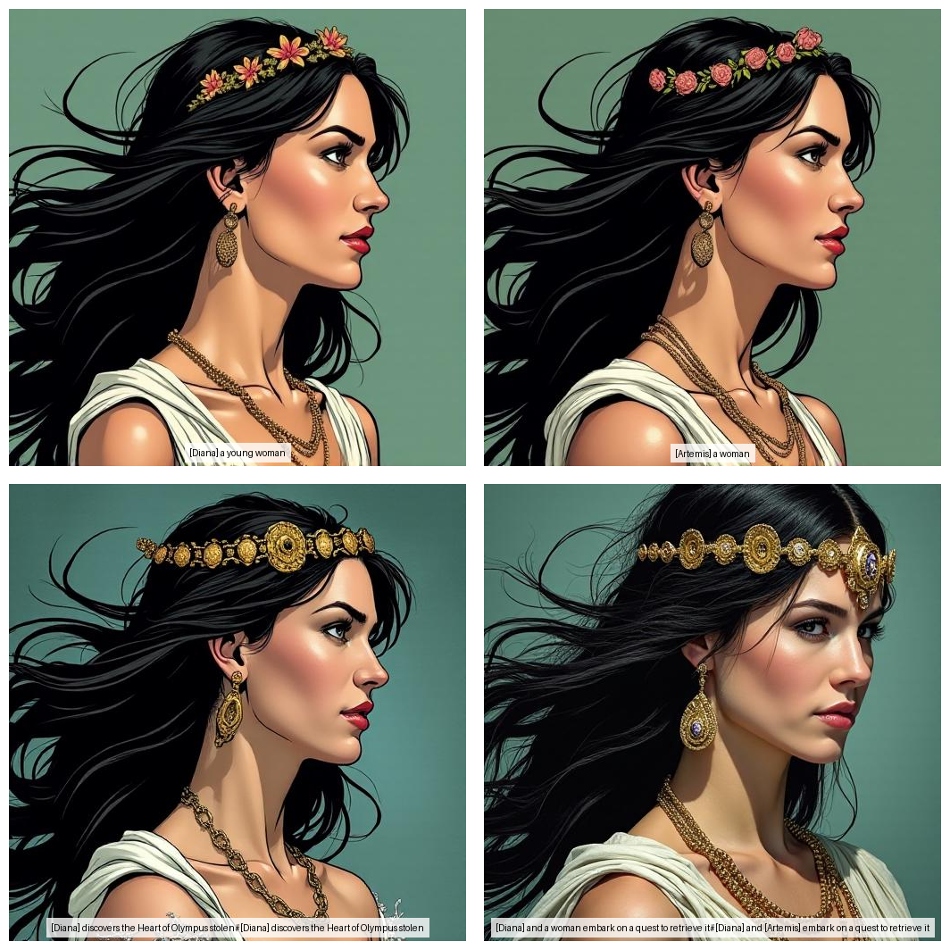

# Chapter 3: Allies Unexpected

As Diana, Artemis, and Cassandra venture deeper into the treacherous lands surrounding Themyscira, they encounter unexpected allies—a group of ancient heroes and demigods who have been living in exile. These allies, once revered for their valor and deeds, have been hidden away, their legends almost forgotten. Among them are Heracles, the mighty demigod known for his strength and courage, and Atalanta, a swift and skilled huntress with unmatched archery skills. Heracles approaches Diana, his eyes filled with determination. 'We have been waiting for someone like you, Diana,' he says. 'Someone to lead us back into the light and help us reclaim our honor.' Atalanta, standing beside him, nods in agreement. 'Together, we can track down the thief of the Heart of Olympus and restore peace to Themyscira.' The group forms a formidable team, each member bringing their unique skills and talents to the quest. They navigate through dense forests, cross treacherous rivers, and scale towering mountains. Along the way, they face magical traps set by ancient guardians and formidable foes sent by Ares to hinder their progress. Cassandra's visions prove invaluable as she guides the team through the most perilous paths. Her foresight allows them to avoid deadly pitfalls and make strategic decisions that keep them one step ahead of their enemies. Her tranquil demeanor and ethereal presence provide a calming influence amidst the chaos of battle. Artemis, with her unmatched combat skills, leads the charge in every encounter. Her arrows fly true, striking down enemies with precision and grace. Her stern expression and focused demeanor inspire confidence and courage in her allies. Diana, at the heart of the team, fights with unwavering determination and compassion. Her Lasso of Truth ensures that no enemy can deceive them, and her strength and agility are a match for any foe. Together, they forge a bond of trust and camaraderie that strengthens their resolve and unity. 'Keep moving!' Diana commands, her voice steady and strong. 'We're almost there.' As they journey deeper into the unknown, the team faces their most challenging trials yet. The lands they traverse are filled with ancient secrets and hidden dangers, but with each victory, they grow stronger and more united. Their quest to retrieve the Heart of Olympus becomes not just a mission, but a symbol of hope and redemption for all who have been forgotten and exiled. Through their combined efforts, they uncover clues that lead them closer to the thief, their resolve unwavering in the face of adversity. The chapter ends with the team standing at the edge of a dark, foreboding forest, ready to face whatever lies ahead, their unity and determination stronger than ever.

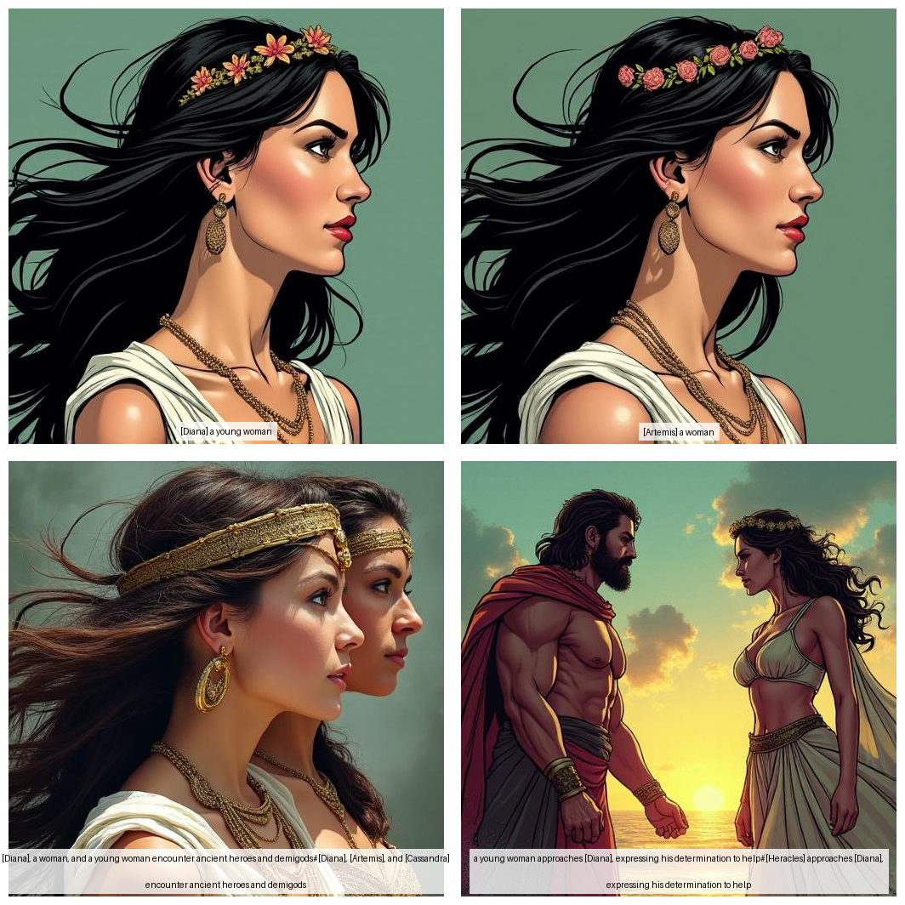

# Chapter 4: The Shadow War

As Diana and her allies get closer to the thief, they uncover a sinister plot by Ares, a powerful and cunning demigod seeking to overthrow the gods of Olympus. Ares has stolen the Heart of Olympus to unleash chaos on the world. The landscape is filled with ominous shadows, and the air crackles with malevolent energy as Ares's forces, comprised of mythical beasts and dark warriors, close in. Diana's Lasso of Truth glows fiercely, revealing the hidden intentions of their foes. Artemis's arrows fly true, striking down the shadows that seek to engulf them. Cassandra's visions guide them through treacherous terrain, avoiding deadly traps set by Ares. The battle reaches its climax as Diana faces Ares in a duel, her strength fueled by the unwavering support of her allies. With a mighty clash, they fight, each blow echoing like thunder. Diana's resolve never wavers, and with a final, decisive strike, she gains the upper hand, driving Ares back. However, Ares's cunning knows no bounds, and he manages to escape, leaving behind a trail of destruction and a warning that the war is far from over. Diana and her allies regroup, wounded but determined, knowing that the true battle lies ahead.

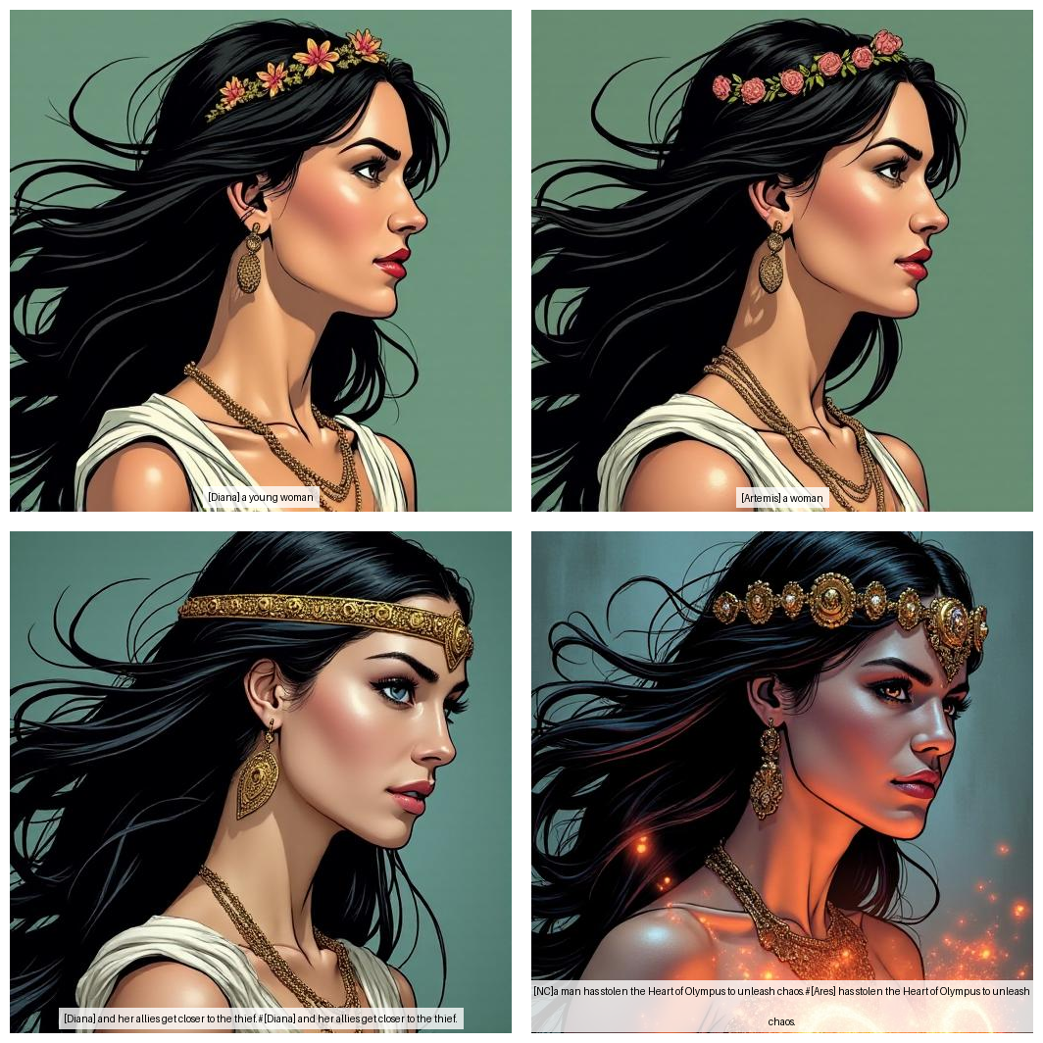

# Chapter 5: Echoes of Olympus

In the climactic final chapter, Diana and her allies face the ultimate battle to reclaim the Heart of Olympus and restore balance to Themyscira. The group stands before the grand temple of Olympus, the winds of chaos swirling around them. Ares, with his dark forces, challenges them, his eyes burning with ambition and hatred. Diana takes a deep breath, her heart filled with determination. She steps forward, her Lasso of Truth glowing with power. Beside her, Artemis notches an arrow, her expression focused and unyielding. Cassandra stands with her eyes closed, her hands raised, drawing on the power of her visions to guide their every move. The battle begins with a flurry of arrows and a clash of metal. Ares's forces, a dark horde of mythical creatures and corrupted warriors, pour forth. Diana and Artemis fight side by side, their movements synchronized from years of training. Diana's lasso ensnares their foes, bringing truth and justice, while Artemis's arrows strike true, felling their enemies. Cassandra's visions provide warnings seconds before attacks, allowing the team to dodge and counter with precision. She chants ancient incantations, summoning protective shields and mystical barriers to deflect the worst of Ares's assaults. 'Diana, watch out!' Cassandra shouts, her eyes flashing open. Diana swiftly dodges a sudden attack, her lasso lashing out to bind her attacker. Ares himself challenges Diana, his spear clashing against her bracers. The battle rages on, the fate of Themyscira hanging in the balance. Diana's courage never wavers. With a mighty roar, she hurls Ares back, her lasso binding him, forcing him to face the truth of his actions. 'You will not win, Ares,' Diana declares, her voice resonating with conviction. 'The power of love and truth will always prevail over darkness and deceit.' Ares struggles, but the lasso holds firm. In a moment of realization, he sees the futility of his ambitions. Defeated, he falls to his knees, his dark forces dissipating. 'You have shown me the error of my ways, Diana,' Ares says, his voice filled with remorse. 'I was blinded by power and ambition.' Diana shows mercy, allowing him to live but banishing him to the farthest reaches of the world, where he can do no more harm. The Heart of Olympus is returned, and the protective barrier around Themyscira is restored. The comic concludes with a celebration of victory. The Amazons gather, their hearts filled with joy and gratitude. Diana stands before them, her armor gleaming, her spirit unbroken. She renews her commitment to protect the world from future threats, her gaze fixed on the horizon, ready for whatever challenges lie ahead. 'Today, we celebrate our victory,' Diana says, her voice carrying across the crowd. 'But we must always remain vigilant. The world needs heroes, and we will be ready.'

